Pokhara University

Level: Bachelor | Semester – Spring | Year : 2008
Programme: BE |  | Full Marks: 100
Course: Filter Design |  | Time : 3hrs.

Candidates are required to give their answers in their own words as far as practicable.
The figures in the margin indicate full marks.

Attempt all the questions.

 | - Define filter. Illustrate different types of filters according to their frequency response in terms of gain and attenuation.  - Determine the orders of the Butterworth and chebyshev response to meet the following specifications.  W_{s=} 2.33 , Wp=1, α_{max} =0.5 dB , α_{min} = 22dB | 7  8
 | - Explain Inverse Chebyshev response with its ideal characteristics and compare it with Butterworth response.  - Realize the third order Butterworth Low Pass Filter for the singly terminated arrangement as shown below.  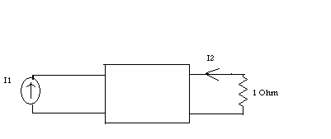 | 8  7
 | - Consider below the designing of a fourth order Butterworth filter with half power frequency of w₀=300Krad/s.Source and Load impedance are R= 4 KΩ. The Design should make use of FDNRs.  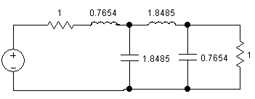  - Realize the transfer function corresponding to the bode plot given below using Active Circuits.  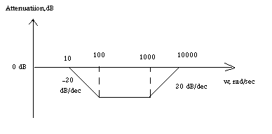 | 7  8
 | - What is the significance of frequency transformation in filter design? Use frequency transformation to find the Band Elimination filter network assuming low pass network.  - What is Single Parameter Sensitivity and Multiparameter Sensitivity. Perform Sensitivity analysis for series RLC circuit and Sallen Key biquad. | 7  8
 | - Draw basic Multiple Feedback Biquad (MFB) Circuit show its Transfer function then design a MFB (low pass) for G=5, b₁=1.2 and b₀ = 1.Make Proper Assumption.  - Design a Butterworth Low Pass filter using sallen and key Bi-quad for the section shown below. The cut-off frequency of the filter is 2π * 1000 rad/sec and use 0.1μF capacitance in the final circuit (use equal elemental value design criteria of sallen and key).  G/(s² + 1.847759s + 1)  V₁ V₂ | 7  8
 | - What are the steps to design higher order filter? Explain with suitable example.  - Design a Switched Capacitor filter to realize the following transfer function.  T(s) = (s + 200)(s + 600)/(s+400)(s+400) | 7  8
 | Write short notes on (Any Two):  - Insertion Gain and Insertion Loss  - Time, Phase and Group Delay  - General Impedance Converter | 2×5

